.
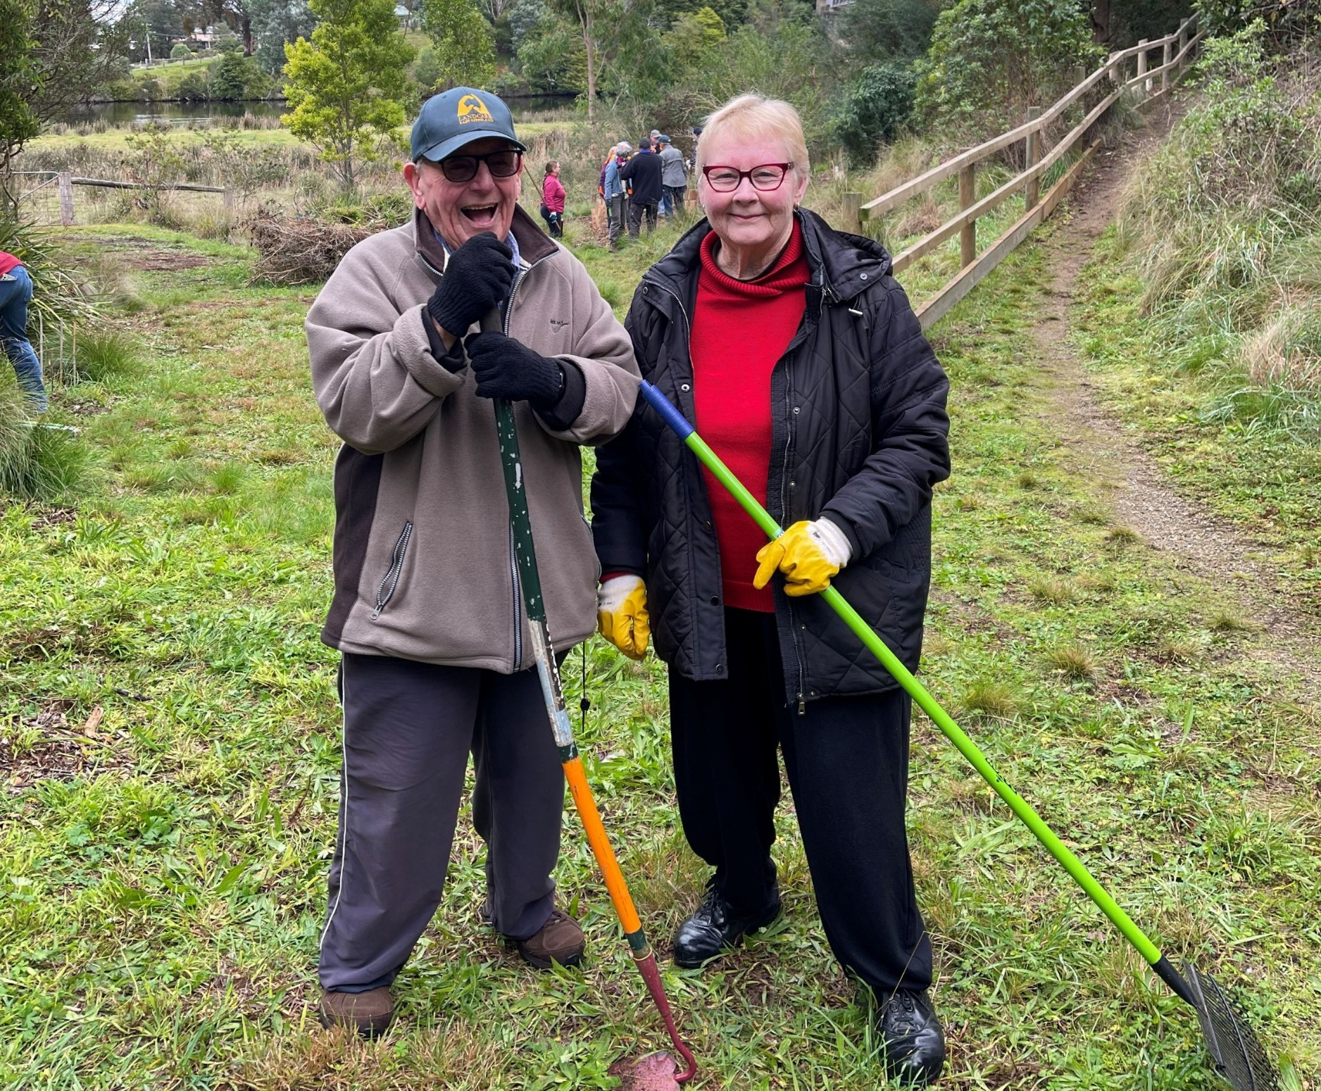


Victorian Government Landcare Grants

East Gippsland

Guidelines 2026
  - Applications close: 5:00 PM Thursday 23 April 2026

Photo Credit:
Credit: Gary and Marion Dawson, Nicholson River Landcare Group
Our commitment to inclusion and diversity
The Victorian Government Landcare Program supports liveable, inclusive and sustainable communities. The Victorian Government Landcare Program supports a Landcare and environmental volunteering culture that is diverse in ability, gender, sexuality, age, socio-economic status, and cultural and linguistic background. The Victorian Government Landcare Program believes everyone has the right to feel safe, welcome and have their life experience valued. Fostering diversity and inclusion helps people to learn from each other and develop new ways to work effectively.
We acknowledge and respect Victorian Traditional Owners as the original custodians of Victoria’s land and waters, their unique ability to care for Country and deep spiritual connection to it.
We honour Elders past and present whose knowledge and wisdom
has ensured the continuation of culture and traditional practices.
DEECA is committed to genuinely partnering with Victorian Traditional Owners and Victoria’s Aboriginal community to progress their aspirations.

© The State of Victoria Department of Energy, Environment and Climate Action March 2026.
Creative Commons
This work is licensed under a Creative Commons Attribution 4.0 International licence, visit the Creative Commons website (http://creativecommons.org/licenses/by/4.0/).
You are free to re-use the work under that licence, on the condition that you credit the State of Victoria as author. The licence does not apply to any images, photographs or branding, including the Victorian Coat of Arms, and the Victorian Government and Department logos.
Disclaimer
This publication may be of assistance to you but the State of Victoria and its employees do not guarantee that the publication is without flaw of any kind or is wholly appropriate for your particular purposes and therefore disclaims all liability for any error, loss or other consequence which may arise from you relying on any information in this publication.
Accessibility
To receive this document in an alternative format, phone the Customer Service Centre on 136 186, email customer.service@delwp.vic.gov.au, or contact National Relay Service on 133 677. Available at DEECA website (www.deeca.vic.gov.au).

Contents
2026 Victorian Government Landcare Grants in East Gippsland 2
What are the Victorian Government Landcare Grants? 2
How much funding is available? 2
Eligibility Requirements 2
Ineligible applicants 3
What type of grants are available? 3
When do applications close? 3
2026 Group Health Survey 3
Project Grant Requirements 4
What could be funded? 4
What won’t be funded? 4
Project location and mapping 5
Aboriginal cultural heritage 5
Do I need to contribute towards my project’s budget? 6
How will my application be assessed? 6
How do I apply? 6
Questions 6
Appendix 1: How will my application be assessed? 7
Appendix 2: Useful information and resources 9

2026 Victorian Government Landcare Grants in East Gippsland

What are the Victorian Government Landcare Grants?
The Victorian Government is providing funding to support Landcare and environmental volunteer groups/networks with on-ground works, community education and engagement activities, group/network development projects that:
- protect and restore the natural environment
- expand participation and engage new and diverse volunteers
- enhance knowledge and understanding of the natural environment
- support recovery from natural disasters
- recognise Traditional Owners’ longstanding connection to Country and support Traditional Owners aspirations in healing and ongoing care for Country and culture
- sustain and develop groups/networks
Victorian Government Landcare Grants:
- fund projects that address local, regional and state environment priorities, delivering:
- on-ground works
- community education and engagement
- group/network development activities
- support local Landcare and environmental volunteer groups and networks with projects and activities in their area, particularly those whose continuing existence will benefit from this support.

How much funding is available?
A total of $3.55 million is available for the Victorian Government Landcare Grants in 2026.

Eligibility Requirements
Who can apply?
You can apply if you:
- are a Victorian Landcare or environmental volunteer group/network that is community-led and has a focus on on-ground land and natural environment improvement work. This includes:
- Landcare groups/networks
- Friends of groups
- Conservation Management Networks
- Coastcare Victoria groups
- Committees of management
- Aboriginal groups/organisations working on Country
- *Cross-state border Landcare and environmental volunteer groups/networks that have Victorian member groups are eligible to apply for grants that are delivered in Victoria.
You must also be:
- an incorporated association
or
- affiliated with Landcare Victoria Incorporated as a member group. See: Landcare Victoria Inc. Member Group Grants Policy for more information
All applicants must:
- hold valid Public Liability Insurance of at least $20 million; AND
- Volunteer Personal Accident Insurance
(Landcare Victoria Inc. members automatically meet these insurance requirements.)
Please note, if your group requires an auspice, you must still hold your own insurance.
If your group/network doesn’t meet the above incorporation requirements, you can still apply for funding, but you’ll need to operate under the auspices of a sponsor organisation that meets these requirements. Please note, if your group requires an auspice, you must still hold your own insurance. You will need to supply written approval (such as supporting letter) from your sponsor (auspice) as part of your application.
See ‘Do we need an auspice’ on page 9.

Ineligible applicants
You can’t apply if you’re a:
- private company
- private individual
- Australian Government agency
- Catchment Management Authority
- industry body
- Local Government
- State Government statutory body/authority
- water authority
If you previously received Victorian Government funding and have outstanding reporting, you are ineligible until overdue reporting requirements are met.

What type of grants are available?
Project Grants |  | Support Grants
If you’re a group/network, you may be eligible for funding of up to $20,000 for:  - on-ground works, community education and engagement, and group/network development activities that protect or improve natural assets such as native vegetation, native fauna, waterways, wetlands and soils.  Note: You must complete your project and report on it by 30 November 2027  You can submit more than one application. |  | If you’re a group/network, you may be eligible for funding of up to $500 for:  - assistance with costs such as insurance, incorporation and operational needs.  Note: You can apply for both Support and Project Grants, but if you receive a Project Grant, you won’t get a Support Grant.
Please read these guidelines before completing your application https://delwp.smartygrants.com.au/2026VLG-EGCMA |  | Please read the eligibility requirements in these guidelines before completing your application https://delwp.smartygrants.com.au/2026VLG-EGCMA

When do applications close?
Applications close at 5:00 PM on Wednesday 23 April 2026.

2026 Group Health Survey
You must complete the 2026 Group Health Survey as part of your application.
The information from the survey is vital for understanding the health of Landcare and other environmental volunteer groups/networks across Victoria. Data is used in Catchment Management Authority and Victorian Government planning, reporting and communications.

Project Grant Requirements

What could be funded?
These grants could fund up to $20,000 for projects that:
- are delivered within the East Gippsland CMA region
- deliver activities to protect or improve natural assets such as native vegetation, native fauna, marine and coastal environments, waterways, wetlands and soils including:
- on-ground works such as revegetation, artificial habitat creation, weed control, pest plant and animal control, protective fencing, and soil stabilisation (conditions apply to some works – see ‘What won’t be funded’ below)
- community education and engagement activities such as property planning courses, field days, education events, demonstration sites and knowledge-gathering (e.g. surveys)
- group/network development activities such as developing a strategic plan, succession planning, and expanding the volunteer base
- meet the following conditions:
- project management costs must be specific to the project and can’t exceed 15% of the total funding requested. Costs may include salary for a paid project manager, project organisation and delivery. Project reporting, printing and office space can be included in this cost.
- communication, including advertising, marketing and promotion included as a separate cost to project management
- total cost of capital items can’t exceed $3,000. You’ll need to show a clear need and community benefit for any capital items included in your budget. Capital items are long-lived items that can be re-used for other projects. These items must become your or your auspice organisation’s registered assets.
- group operating costs up to $500, such as insurance, incorporation and operational needs, should be included as a separate budget line in your project.
- ensure health and safety, cultural heritage and biodiversity impacts have been considered, particularly for eligible activities that have the potential for harm such as warren/den ripping. Allow funds in your budget for this, including any permit requirements and consultation with Traditional Owners.
- can be completed and reported on or before 30 November 2027.
Your group/network can submit more than one project grant application. It is not necessary to apply for both Support Grants and Project Grants. In the application form you can indicate that you would like to receive a Support Grant if your Project Grant application is unsuccessful.
We recommend that your project is designed to be scalable to allow partial funding if full funding isn’t available.
Please contact your Regional Landcare Coordinator to discuss your project and how it relates to regional priorities before you apply.

What won’t be funded?
The following activities won’t be funded:
- Amenity and beautification projects
- Shooting, poisoning, trapping, explosive or fumigation* methods for pest animal control, including engaging a contractor to undertake these activities
*While ripping is still the preferred control method, fumigation for pest rabbit control may be funded if the following conditions are met:
        - Works take place on public land
        - Ripping can’t be conducted – e.g. where there are threatened flora and vegetation communities listed under the Flora and Fauna Guarantee Act 1988 - Threatened List present
        - Written approval is provided by the land manager
        - Works are carried out by a contractor holding a valid Commercial Operator License (COL) and Agricultural Chemical Users Permit (ACUP).
        - Preferably includes a combination of both methods, not solely fumigation.
- Boundary fencing and barbed-wire fencing
- Non-indigenous vegetation
- Vegetation corridors less than 10 metres wide. Minimum project width of 10 metres is required (minimum 10 metres from the top of the bank in riparian areas). Contact East Gippsland CMA regarding regional-specific requirements
- Actions or costs associated with native vegetation offset sites or activities
- Control of some weed species. Please limit funding for weed control to species on the Advisory list of environmental weeds in Victoria. Discretion may be used where there’s a clear public benefit to control other weed species
- Purchase of capital items over $3,000
- Project management or administration costs that collectively total more than 15% of total funding requested
- Computers, laptops, tablets and smartphones
- Purchase of goods for competitions, prizes, giveaways, vouchers or alcohol
- Any other action/activity determined by the Regional Assessment Panel to be an inappropriate or unsuitable use of the funds.

Project location and mapping
Projects can be on private or public land in Victoria.
You’ll need to map the location(s) of the on-ground component of your project and label project sites with a site ID if working on more than one site. Please attach the map to your application.

Aboriginal cultural heritage
Aboriginal cultural heritage in Victoria, including Aboriginal intangible heritage (traditional practices and knowledge), Aboriginal sites, places and objects is protected under the Aboriginal Heritage Act 2006 and Aboriginal Heritage Act Regulations 2018. It’s our responsibility, as the carers of the land, to respect, understand and protect our Aboriginal heritage.
We recommend that you conduct an Aboriginal cultural heritage check early in the planning stage via the relevant Registered Aboriginal Party or the Aboriginal Victoria Heritage Operations Team.
To determine if your planned project is within an identified area of cultural heritage sensitivity, use the First Peoples State Relations website's online mapping tool.
If your proposed project site is within an area of cultural heritage sensitivity, please refer to the First Peoples State Relations website for more information.
Even if your project isn’t within an area of cultural heritage sensitivity, there still may be Aboriginal sites in the area. If an unregistered Aboriginal site is found during your project delivery, you must STOP IMMEDIATELY and contact Aboriginal Victoria on 1800 762 003.
If a Cultural Heritage Permit is required, you may need to include budget in your grant application and allow 30 days to complete the permit process. For more information contact your Regional Landcare Coordinator, Registered Aboriginal Party or Aboriginal Victoria.
For further guidance please follow the Aboriginal Cultural Heritage Guide.

Do I need to contribute towards my project’s budget?
In the application form you can describe any partnerships the project will have as well as any in-kind skills and resources that will be used to deliver the project. All other in-kind contributions will be captured in the end of project reporting.

How will my application be assessed?
Project Grant applications will be assessed by a Regional Assessment Panel that will consider your project’s contribution to:
- protecting and restoring land and environment in accordance with local and regional priorities
- partnerships and skill development
- demonstrated need and community benefit
- project design and group/network capacity to deliver
- value for money.
More details are provided in Appendix 1.

How do I apply?
APPLY HERE EGCMA 2026 Victorian Landcare Grants
You:
- apply on-line through SmartyGrants.
- can save your application and continue to work on it until you’re ready to submit
- should start your application as early as possible
- can sign up to SmartyGrants with a generic group email and provide that email address and password to whoever needs to contribute to the application. Groups that have an ABN can sign up to SmartyFile which will enable you to pre-fill your group information and view all your SmartyGrants applications in one spot.
Remember:
- the application can only be accessed by one set of login details
- if you don’t own a computer, you can use one at a public library, where technology support is often available
- if internet connectivity is an issue in your area, request a PDF version of the application form from your Regional Landcare Coordinator.
- hard-copy applications won’t be accepted, so if you’re working offline, you’ll need to copy and paste your prepared responses into the online application form to submit once you have internet connectivity. If you require assistance, contact your Regional Landcare Coordinator.

Questions
For any questions or to discuss your application please contact:
Krystel Handley
Regional Landcare Coordinator, East Gippsland Catchment Management Authority,
Email - khandley@egcma.com.au PH - 0419 892 268

Appendix 1: How will my application be assessed?
Eligible Project Grant applications will be assessed against the criteria below.

Table 1. Project Grants assessment criteria
Criteria | Value | Description
Natural environment outcome | 20% | The extent to which the project contributes to protecting and restoring the natural environment.
Partnerships and skill development | 20% | The extent to which the project uses partnerships and builds on the skills of the group and/or volunteers.
Demonstrated need and community benefit | 20% | Alignment with a natural resource management strategy, such as the Regional Catchment Strategy or Biodiversity 2037, identifying the need for this project or activity and the community benefit.
Project design and group/network capacity | 20% | The ability of the group/network to plan and deliver the project, including group resources and technical feasibility. Priority will be given to eligible projects that are well-planned, achievable and outline the project delivery method. Past project delivery will be considered.
Value for money | 20% | The budget represents good value for money, including itemised costs, budget items are relevant, appropriate, and aligned with the scope/scale of the project and a clear justification is provided.
In addition to the above criteria, the assessment panel will also consider:
- overall mix of project types, locations and geographic coverage
- overall mix of groups/networks to be supported

What happens after applications close?

Assessment process
The assessment panel will assess your application based on the information you provide.
The panel may decide to recommend partial funding for some Project Grants and Support Grants.
If you apply for more than one project and one of your projects is funded, preference may then be given to unfunded applicants over your other projects.

Notification of outcome
You’ll be advised of the outcome of your application in writing after the assessment process is completed. All decisions are final and aren’t subject to further review. However, if your project isn’t awarded a grant, you’re welcome to ask for feedback on your application.

If your application is successful
If your application is successful then you’ll have 4 weeks after receiving your letter of offer, including the funding agreement, to submit your organisation’s signed funding agreement, and any other documentation outlined in the letter of offer. If you don’t submit the documentation within this timeframe, the funding may be reallocated to other projects.
You’ll receive payment once all paperwork has been completed and submitted. If you have an auspice, they’ll receive the payment on your behalf.

Funding conditions
If you’re successful, you or the auspice organisation (if an auspice is used) is required to:
- enter into a funding agreement with East Gippsland CMA
- be responsible for meeting contractual obligations to deliver the project and submit project reports by 30 November 2027
- adhere to all relevant legislation including OHS requirements
- acknowledge the East Gippsland CMA and Victorian Government funding in publications and promotions
- confirm that the activity doesn’t include using the funding for political campaigning or advocacy activities for political parties.

Reporting requirements
Once the project is complete, you’ll need to submit a report online using the reporting template provided through SmartyGrants. The reporting template will be open throughout the project delivery phase.
Your report must include:
- how you spent the grant (keep receipts and tax invoices, as these must be produced on request)
- what you achieved with the funding for the protection and restoration of land and environment
- data that you collected during the project (data may be made publicly available)
- what you learned while completing the project
- how the project will support the group, network or partnerships into the future
- images of the project, including on-ground works and/or capacity building activities and/or community education and engagement activities (images may be made publicly available and will require consent release forms).

Appendix 2: Useful information and resources

Regional Catchment Strategy
The East Gippsland Regional Catchment Strategy EGCMA | Plans, Strategies & Reports provides an integrated planning framework for managing land, water and biodiversity resources, and sets out regional objectives and priorities for their protection and improvement. You should design your projects to make clear contributions towards Regional Catchment Strategy objectives and priorities.

Do we need an auspice?
If your organisation doesn’t meet the incorporation eligibility requirements, you must partner with another organisation, known as an auspice. All unincorporated organisations that aren’t financial members of Landcare Victoria Inc. will need an auspice to apply for a grant.
You’ll need approval from your auspice before applying for a Victorian Landcare Grant. That organisation will be legally responsible for delivering and administering your grant on your behalf.
An auspice must:
- be either an incorporated association registered with Consumer Affairs Victoria or a Victorian Government/ statutory body/authority
- hold at least $20 million of public liability and personal accident insurance
- sign the funding agreement and receive the grant payment
- be responsible for delivering and reporting on the project
Potential auspice organisations may include:
- local governments
- Victorian Government agencies, e.g. Parks Victoria
- statutory authorities
- umbrella not-for-profit associations, e.g. Landcare Victoria Inc. or Landcare/community networks in your area.
Important: Your group must still hold insurance in its own name. Having an auspice does not meet the insurance requirements for your group.

Landowner and Land Manager consent
All projects that involve on-ground works, events or community activities will need support from the landowner or land manager.
If your project is on land owned or managed by more than one organisation/person, you’ll need support from each separate landowner or land manager.
Public land – including Parks Victoria, local council and Department of Energy, Environment and Climate Action (DEECA)
A letter or email demonstrating in-principle support is sufficient for your grant application. If your project is successful in receiving funding, seek formal approval before works start. Formal approval may take time – ensure you’ve taken this into account when designing your project. Check whether any permits are required and what costs are involved.
Provide evidence of land manager consent/support in your application. For advice about land manager consent please refer to following relevant contacts:
- Parks and reserves – contact Parks Victoria on 13 1963 or your local Parks Victoria staff
- Crown land – contact DEECA on 136 186 or through your local DEECA office
- Contact your local government authority.
Private land
List landowner details (name and address) in your application for all private properties where on-ground works will be taking place. If your application is successful, you’ll be required to confirm that you can provide evidence of private landowner's consent for on-ground works to take place upon request.

Protecting Victoria’s Environment – Biodiversity 2037
Protecting Victoria’s Environment – Biodiversity 2037 is Victoria’s plan to stop the decline of our native plants and animals and improve the natural environment, so it is healthy, valued and actively cared for. Find out more about how the plan is being implemented here.
Naturekit is a free online mapping and data exploration tool that displays biodiversity information and supports investment and management decisions to deliver Biodiversity 2037. It includes the Strategic Management Prospects (SMP) decision support tool. SMP assesses the cost-effectiveness of landscape-scale actions across Victoria and compares the benefit these actions will have for the species at each location, helping to inform priority actions. To do this, it combines evidence-based models for thousands of plant and animal habitats, major threats to their survival and indicative costs of management. SMP can be a useful resource when considering the potential biodiversity benefits of landscape-scale management actions at a location.
Biodiversity Response Planning is an area-based planning approach to biodiversity conservation in Victoria. We encourage you to consider the Focus Landscapes fact sheets prepared by DEECA regional staff with stakeholders in 2020. These describe each Focus Landscape, including the species or communities that occur there, threats and actions to take that will achieve the best outcomes for biodiversity in that landscape. Use the fact sheets to help design your project. Fact sheets can be found on the Biodiversity Response Planning – Working together for biodiversity website.

Volunteering for Nature – Environmental Volunteering Plan
The Volunteering for Nature – Environmental Volunteering Plan (2018) addresses the opportunities, challenges and changing needs of the environmental volunteering sector to help volunteers do more for nature when, where and how it suits them.

Invasive Plants and Animals Policy Framework
The Invasive Plants and Animals Policy Framework represents the Victorian Government's approach to managing existing and potential invasive species across the state. The framework expands the Victorian Government’s vision for what invasive species management can achieve for the Victorian community. For more information about declared noxious weeds and pest animals, please visit the Consolidated lists of declared noxious weeds and pest animals website and the Advisory list of environmental weeds in Victoria.

Aboriginal Cultural Heritage resources
You must meet the requirements of the Aboriginal Heritage Act 2006 and determine if a Cultural Heritage Permit is required. More information is available at:
Aboriginal Cultural Heritage Guide for Landcare and environmental volunteering groups
Cultural Heritage Sensitivity
Online Map Tool
Registered Aboriginal Parties

Occupational Health and Safety (OH&S)
You must have a safe system of work in place to protect the health and safety of your group, volunteers and anyone else on your project site.
OH&S resources tailored to community groups include:
WorkSafe Victoria

Fencing Standards
Please check that your application meets the standards set out in the Output delivery standards for the delivery of environmental activities (PDF, 1.4 MB)
For more information visit www.deeca.vic.gov.au/output-data-and-delivery-standards

Child Safe Standards
Child Safe Standards apply in Victoria. The Victorian Government has zero tolerance for child abuse and is committed to ensuring the safety of children. It takes deliberate steps to protect children from physical, sexual, emotional, psychological and cultural abuse and neglect and creates a culturally-safe environment for all children.
Organisations operating in Victoria, including community‐based organisations, that provide service or facilities where children are involved are required to meet Child Safe Standards. More information on Child Safe Standards can be found on the Commission for Children and Young People website.

Incorporation Eligibility Requirements
Your organisation may become:
- an incorporated association registered through Consumer Affairs Victoria
- affiliated with Landcare Victoria Incorporated as a member group. See: Landcare Victoria Inc. Member Group Grants Policy for more information
- an incorporated association registered through the Office of the Registrar of Indigenous Corporations.

GST
The maximum grant available for a Project Grant is $20,000 GST free.
All payments require payment of GST to GST-registered organisations.
As an example, 2 groups apply for a $20,000 grant.
Group A is not registered for GST and Group B is registered for GST. Group A will be required to invoice for $20,000. Group B will be required to invoice for $22,000 (inc. GST) and claim a GST credit back through the ATO.
You’ll need to work out the costs of your project that need to be funded by the grant (to a maximum of $20,000). This may include taxable supply items such as plants and materials which include a GST charge. In the project budget include each item for which you are requesting grant funding and its total cost.







EGCMA | Home

